**Ecotone Monitoring Wells**

We will be installing eight ecotone water level logging devices at reference sites within CVNP (Maps attached). The two Riverine Mainstem wetlands (1427 and 970) will have data loggers installed to nearly 80 inches below ground. The remaining 6 wetlands will have the 40 inch data loggers. Each will have a unique identification number. See the attached figure to view the basic construction and dimensions of the ecotone loggers.

Ecotone Serial Numbers

1. 00001130EF2B (40 in)
2. 00001130CD9C (40 in)
3. 000011312BFF (40 in)
4. 00001130EC9B (80 in.)
5. 0000138BC062 (40 in)
6. 0000138BC5C4 (40 in)
7. 0000136B51B5 (40 in)
8. Purchase in 2010 (80 in)

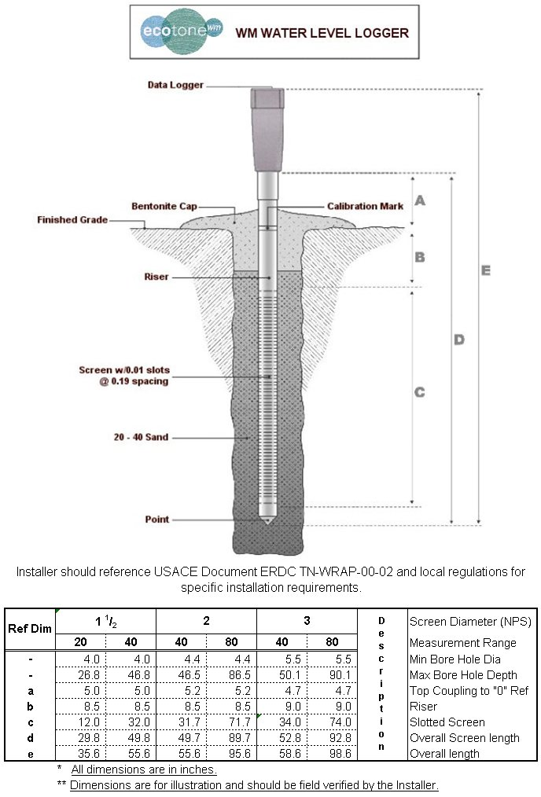

Well Installation (40 inch loggers)

The well screen should be located through subsoil horizons where water tables are expected to fluctuate.

1. Lay plastic tarp down next to plot center point where well will be installed.

2. Using a 3-in bucket auger, begin to auger hole at well location. Auger down approximately 8 in. at a time, laying out soil cores from the auger bucket end to end on tarp for stratigraphic description.

3. Auger to and approximately 1.2 m below the ground level. It is good to install wells as late in the season as possible, when water tables have had the opportunity to drop.

4. Record depth to saturated soil and observations of soil texture, soil matrix color using a Munsell color chart, and the presence of hydric soil indicators such as mottles, oxidized root channels, or gleyed colors on site establishment form.

5. Once a hole is at sufficient depth, test fit well.

6. Making sure pipe is vertical and centered in hole, backfill with sand and excavated soil, as necessary. Care should be taken during backfilling to ensure no large voids are present. Top off with Bentonite clay at surface.

Well Installation (80 inch loggers)

The 80 inch loggers will likely require more disturbance. We do not have augers that are large enough to dig the 80 inch holes so the installation protocol must be modified for these 2 locations. This could require using heavy equipment to dig a small trench for the top 40 inches, then use the auger for the bottom 40 inches. We would back fill using the existing soil, except for the sand and bentonite layers illustrated in the figure.

Proposed Locations (next 7 pages):

